Note: I have written justifications of the space complexity in the form of comments under the program code.

Program 1: Write a C program to find sum of 1st n natural numbers using user-defined functions
Program:
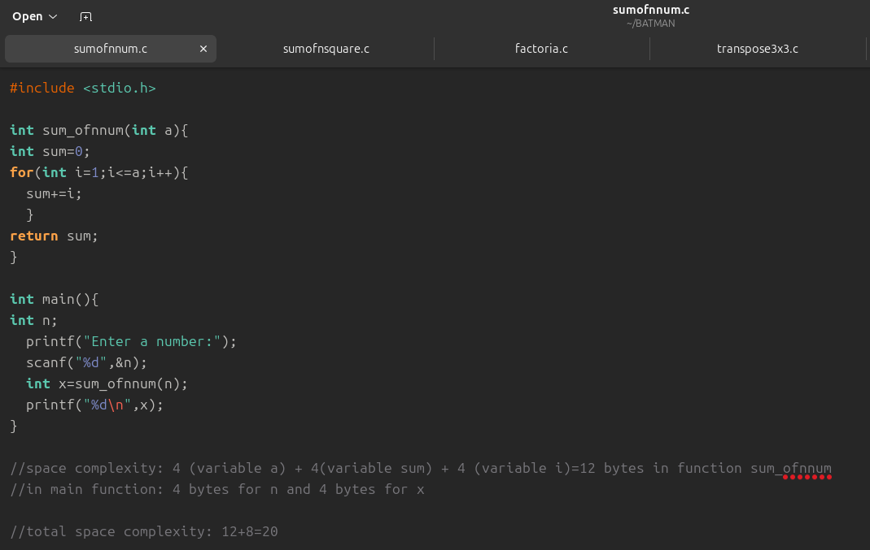
Output:
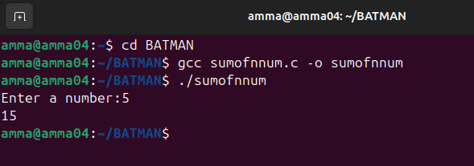

Program 2: Write a Program to find sum of squares of first m natural numbers
Program:
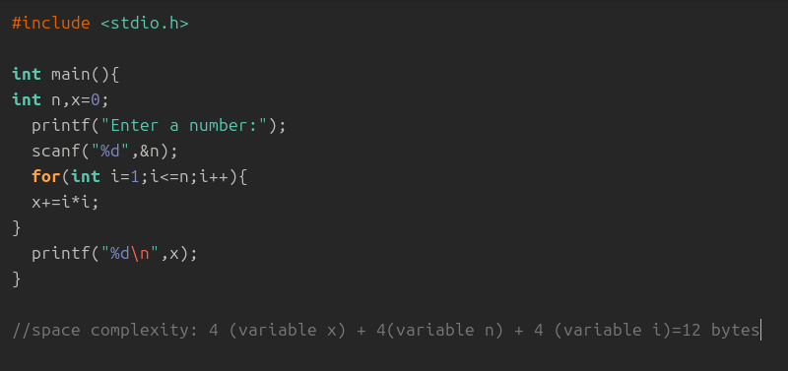Output;
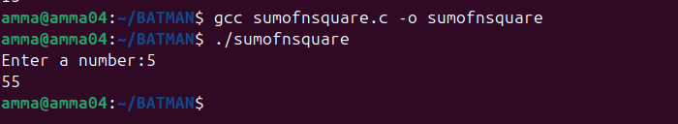Verification: 1+4+9+16+25=55

Program 3: Write a Program to find sum of n cubes of first o natural numbers – no need of user defined functions
Program:
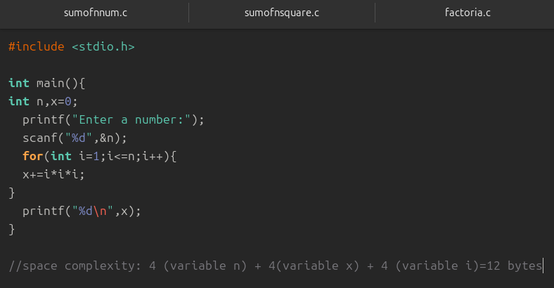Output:
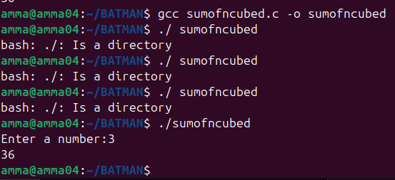
Program 4:
Write a program to find factorial of a given integer using recursion.
Program:
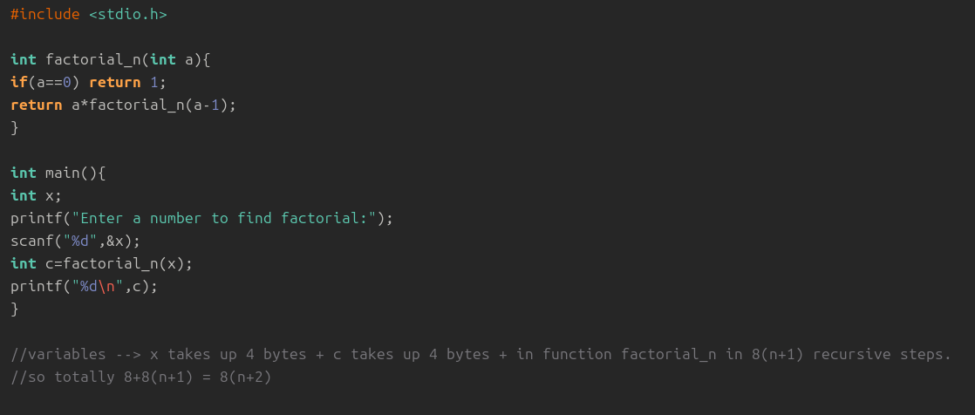
Output:
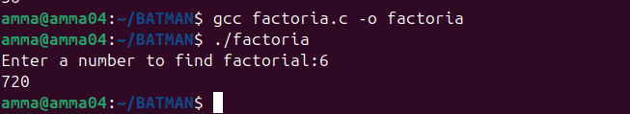

Program 5: Write a Program for transposing a 3x3 matrix
Program:
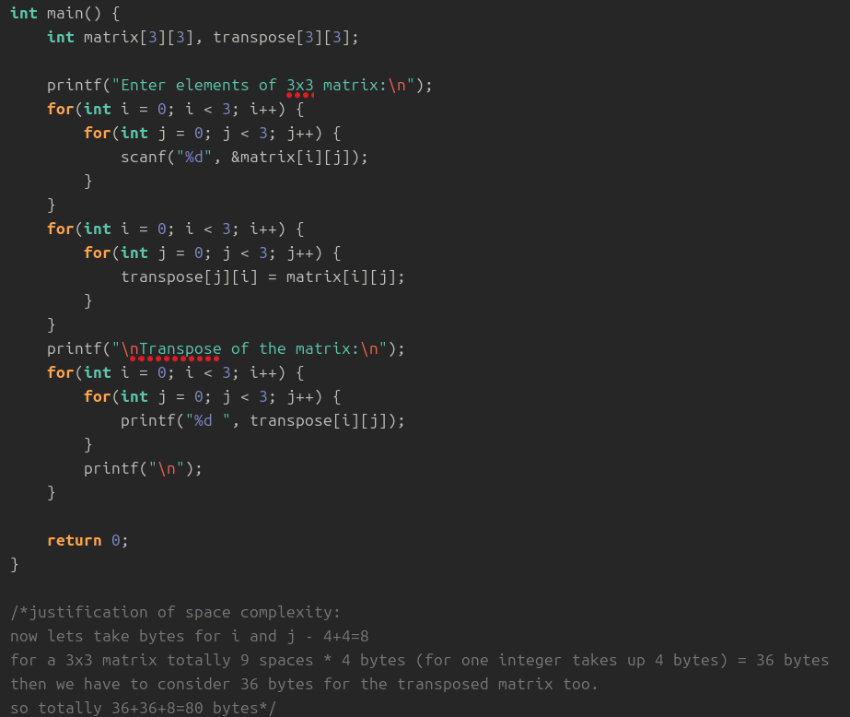

Output: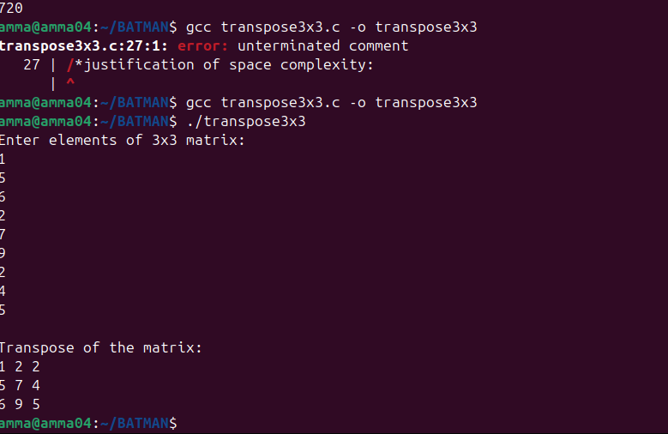

Program 6:
To write a program to find fibonacci series
Program:
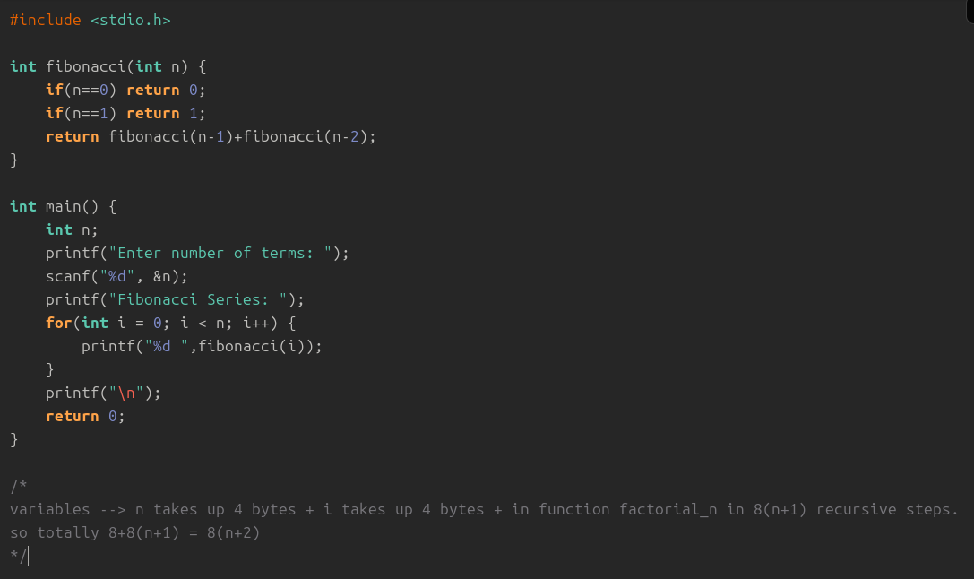
Output:
